Portfolio

Portfolio Examples
Blaw ($1000):
https://barbaralaw.me

Shawn (Amazon - $1495):
https://shawncharles.netlify.app
Persona

Twitter

Nyah (AfrosInAi.com):
https://twitter.com/EarthandCode
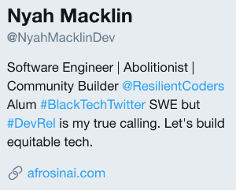

Twitter

Sam (Material UI):
https://twitter.com/tanoaksam
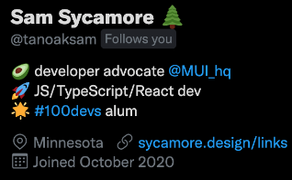

Linkedin
Andy (Draft Kings):

https://www.linkedin.com/in/andy-vasquez-dev/

let developer = true
let designer = false

if(designer === true){
console.log("Design your portfolio")
}else{
console.log("USE A TEMPLATE")
}

Templates
Free (and not shady af):
https://html5up.net

After your first client:
https://wrapbootstrap.com
https://themeforest.net

Hosting
Netlify
Domains
Sometimes you can get the first year free
Namecheap
IWantMyName
OR
Just use netlify.app for free

Find clients
Close
Friends family social Media
Local - Networking
Listings Places I Know Outbound (Build A List/Dial for Dollars)
Go Wide
Gig Sites (Upwork), Forums(Reddit), Build Authority

Payment
Zale
Stripe
Proposal

Proposify (Free)

Panda Doc (Free)

Contracts
Contract killer on github
Sams modification
indemnificatiob clause – important bits
2nd paragrapgh is so I can luse projects for portfolio
Get depostis first 50% upfront then 25 for next milestone next 25 for final completion
Starting out 10%
Magic question – tell me about your project
Take detailed notes
save room for help
Time for help
Communicate regularly
Send client email every week
Reinvest
PORTFOLIO
PROPOSAL
CONTRACT
BUSINESS ENTITY
LAWYER
CPA

USE A PASSWORD MANAGER TO STOR PASSWORDS FOR VLIENTS PROJECT AND SAHRING
AD A WALKAWAYY CLAUSE

